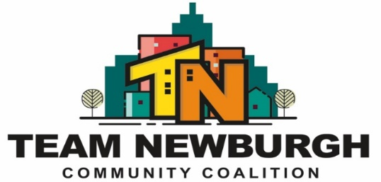
Mission Statement: “Provide Opportunities to the diverse and underserved populations of the greater Newburgh community by encouraging and strengthening partnerships building relationships and utilizing multiple evidence-based prevention and outreach strategies.”
Full Coalition Meeting
Location: Newburgh Recreation Center (401 Washington Street Newburgh, NY)
Date: January 10th, 2024
Topic | Who | Actions/Decisions | Notes:
Welcome/Introductions | Everyone | - Mental Wellness Ice Breaker Activity  - Vote on last month’s minutes
- Special Population Grant | Dawn  Frankie  Erme  Stevenson | - Coalition Capacity Check List  - Youth Poster Contest Update  - Sticker Shock- Volunteers Needed  - Upcoming Coalition Trainings  - Updated website  - CADCA | Coalition Capacity Check List- this was the OASAS survey we have been discussing and some of you have completed. As of right now OASAS has told us 21 of our partners have participated in this. Please refer to previous emails with information and the link if you are interested in participating. The survey will close on January 31st. Youth Poster Contest- We received 10 submissions from the Boys & Girls Club as mentioned at previous coalition meetings. We did have leadership vote on those submissions last week. However, there were submissions from the Heritage Middle School Art Club that seemed to get lost in the mail and were returned back to the middle school. We were able to retrieve them yesterday and received 7 additional posters. We will be scanning all the posters and asking leadership to revote virtually on them. Once winners are chosen prizes and distribution of such will be discussed with leadership. Sticker Shock- As previously mentioned we purchased English and Spanish stickers from Hotline Creations regarding the Orange County Social Host Law which now includes cannabis. These stickers will be dropped off at local restaurants, gas stations, bodegas, etc. These will be used as conversation starters and information on this topic. We are looking to distribute these stickers after the Outreach meeting on Thursday January 25th at 10:00 am please meet at TEAM Newburgh's Office at 280 Broadway. We are looking for volunteers to help drive and drop off stickers to local businesses. If you are interested, please let us know by responding to this email.  Upcoming Trainings- A google form went out asking members which trainings they were interested in for the 2024 coalition year. The top 3 requested trainings include: Drug Trends Overview/Under Your Radar Training (this includes a searching for drug paraphernalia and indication of high-risk behavior items in a mock teen bedroom, items will be revealed and discussed along with current drug trends, resources and import drug information). This training will be provided to the entire coalition at our March coalition meeting. The next training will most likely be about leadership and that will be given in May. May is also mental health awareness month so we can try to do a training about that as a backup.  The last training will be given in October which is Domestic Violence Awareness month. For October we have 2 requested trainings including: Gang Violence Overview, Domestic Violence & Sex Trafficking. (At the next coalition meeting we will be asking the coalition to vote on which training is preferred for October).  CADCA- from January 28th to Feb. 1st we will have 3 staff members out of the office attending this annual conference. We will give a report out on this at our March meeting.
- TEAM Newburgh Upcoming Events | Frankie  Stevenson  Megan | - Agency Soup  - Senior Ball | Agency Soup- In leu of our February meeting we will be hosting Agency Soup at Cornerstone on Feb. 14th from 9:30am-11:30am. Attached is the flyer and registration form. Please feel free to invite any other organization to present that may be new to the area or not already involved with TEAM Newburgh yet. Agency Soup Registration. The Senior Ball is being held on Feb. 21st from 5-6:30pm at Lake Street Senior Apartments in Newburgh. We need coalition members to volunteer to help set up, clean up and deliver food to the residents.
- Sub-committee updates | Stevenson  Carly  Frankie | - Subcommittee Leader Report Outs  - Next Meeting Dates for Each Committee | Outreach Subcommittee next meeting is being held on Thursday January 25th at 280 Broadway Newburgh 10 am.  SUMH/ Education next meeting virtually 10am on January 22nd. Agenda and link will be sent out next week.
- Next Meeting  Feb. 14th, 2024  @ Cornerstone  for Agency Soup | Everyone | - Partner Updates

