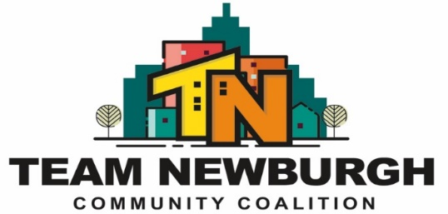
Mission Statement: “Provide Opportunities to the diverse and underserved populations of the greater Newburgh community by encouraging and strengthening partnerships building relationships and utilizing multiple evidence-based prevention and outreach strategies.”
Full coalition
Location: Newburgh Recreation (401 Washington Street Newburgh NY 12550)
Date: June 12th, 2024
Topic | Who | Actions/Decisions | Notes:
Welcome/Introductions | Everyone | - Updates on TEAM Website / new coalition brochures  - Vote on May Meeting Minutes | Erme has updated the TEAM Newburgh brochures and the coalition website. Partners are encouraged to check out the website to make sure their organization is listed as a resource. TEAM Newburgh summer events are on our website along with the information for “Peachy.”  May meeting minute approval:  1st POW’R  2nd NECSD
- General TEAM Newburgh Updates | Megan | - Tri-City Youth Coalition Updates  - No meetings until September  - Update on syringe discussion | The Tri-City Coalition position is being created at CCOSU. A job description will be sent out to the coalition when it’s available. We will be off for the summer with full coalition meetings resuming in September.  HVCS gave an update on the syringe program, along with TEAM leadership members. HVCS has also shared their calendar of outreach dates and will be distributed to the full coalition. They stated the biggest concern is syringes being on private property. Other partners also discussed their concerns. Becky from HVCS is the contact for syringe issues at agencies/organizations.
- TEAM Newburgh Upcoming Events | Stevenson  Megan | - Youth Fishing Trip / sign-up sheet  - Youth Empowerment Basketball Tournament  - Keep it moving – skateboard event (Erme attended)  - TEAM table at Desmond Summer event on 6/20 – partners needed to table | The Youth Fishing Trip will be held on July 17th at Chadwick lake. A sign-up sheet for stations has been created and will be sent to coalition listserv. Church at the Bridge will be providing food via their food truck and it’s also love our city week!  The second annual youth empowerment basketball tournament will be held on August 3rd. Agencies are encouraged to reach out to Stevenson if they would like to have a table. We will also be taking water, juice and other food donations for the kids. Partners are encouraged to bring their own tents, tables etc.  Erme attended the Keep it Moving Skateboard event to give away TEAM information.  TEAM will have a table at the MSMC’s Kick Off to Summer event on June 20^{th,}
- Special Populations | Megan | - “Peachy” the elephant is here! With social host cards (sign-ups begin in sept.)  - PSA with the boys and girl’s club running on K-104  - City council meeting report out  - Frankie back for September coalition meeting | Partners were able to see “peachy” for the first time! The lead up for the campaign has begun and we will have her at all of the TEAM summer events. Partners will be able to host peachy beginning in September.  PSA for Boys and Girl’s club has been running and has established a great reach in the community so far.  Meaghan reported out on the city council meeting last month where she and Erme spoke about the safety zone campaign. They received good feedback from city council.  Frankie will be back as coalition coordinator beginning on July 22nd and will be resuming the coalition meetings in Sept.
- Sub-committee break out & updates | Full coalition members | - Subcommittee Meeting during team meetings moving forward | Both subcommittees met for 15 minutes to discuss summer initiatives and will be meeting again in the summer.
- Next Meeting September 11^{th.} | Everyone | - Partner Updates | Partner sharing:  Project street beat shared information on their program and how they promote harm reduction. They have no syringe exchange program at the moment.  Fearless: spaces still open for their summer program. Offers a lot for the kids in terms of community service.  CCOSU: meet and greet at NFL at 6:15 for the immigration program on Wednesday.  Cornerstone: 1st week of august they are hosting an event and would like partners to table and for food donations. They would also like to run workshops during the event. Contact Lisa and Ralph for more info.  NFL: has a lot of summer events happening. Please check out their social media for flyers.  NYS national guard: focuses on coalition development and encouraged partners to track info they had out for TEAM.  MHA Hudson House: she introduced herself as the new connect and offered her services.

